**Zscaler is a cloud-based security tool that must be enabled to allow your refresh to proceed.**

1. Once you have signed into your new PC, please locate the system tray icon on the taskbar located at the bottom of your desktop:



1. Hover your curser over the Zscaler icon. If it is blue and states that it is enabled, no further action is required.

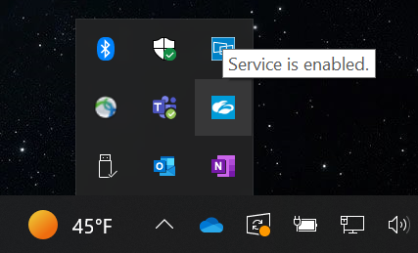

1. If it is not, please left click on the Zscaler icon, select Open Zscaler, and complete the sign in process using the same account you used to sign into the PC with.

Thank you for setting up your Zscaler,